Developing design skills requires exposure to diverse environments that foster creativity, critical thinking, and hands-on experience. Design studios and agencies offer a professional setting where aspiring designers can immerse themselves in real-world projects and collaborate with seasoned professionals. These environments provide invaluable opportunities to learn industry standards, refine technical skills, and gain insights into the creative process from conception to execution. Moreover, working alongside peers and mentors in a studio setting encourages collaboration, constructive feedback, and continuous learning, all of which are essential for growth and development as a designer.

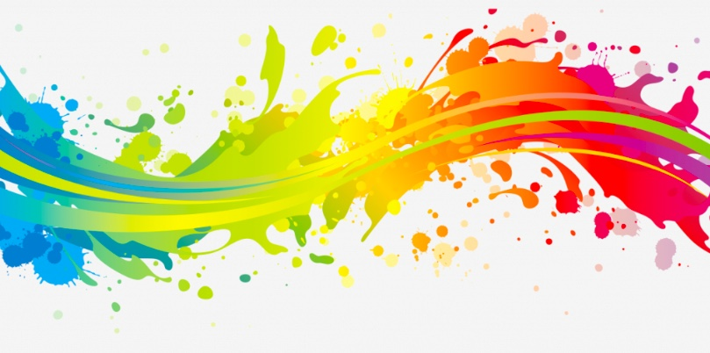

Educational institutions, such as art schools and design academies, provide structured programs and resources tailored to aspiring designers at various skill levels. These environments offer access to experienced faculty, state-of-the-art facilities, and a curriculum designed to cultivate both technical proficiency and creative thinking. Students benefit from hands-on projects, critiques, and workshops that challenge them to explore different design principles, experiment with various mediums, and develop a personal style. Moreover, academic environments often foster a vibrant community of like-minded individuals, providing opportunities for networking, collaboration, and exposure to diverse perspectives that enrich the learning experience.

Online platforms and communities have revolutionized the way designers learn and connect with others in the field. Websites, forums, and social media channels offer a wealth of resources, tutorials, and inspiration accessible to designers of all levels, regardless of geographic location. These virtual environments enable designers to showcase their work, seek feedback, and engage with a global community of peers, mentors, and industry experts. Moreover, online courses and workshops provide flexible learning opportunities tailored to individual interests and schedules, allowing designers to acquire new skills, explore emerging trends, and stay updated on the latest tools and technologies shaping the field of design.